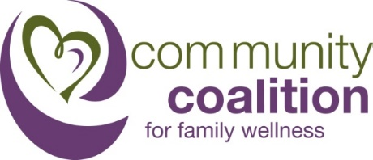
PEC Meeting:
Wednesday, January 18th 2017
3:15 pm

- Welcome: Introduction and merging of the Committees
    - New Committee Goals:
      - Name Ideas?
    - Brain storming: Creating a marketing campaign for all 3 with a Data Walk.
      - Parent Engagement- Super Power Your Parenting
      - Drug Elimination- Reduce the Meds-
            - High School Marketing classes
            - Self-created images
      - Law Enforcement Committee
            - Where do we put the LED Sign?
            - What messages?
    - New Programs for February
      - May 10th Community Forum
        - May 10th Community Forum- Speaker Ideas?
      - Press Releases- February
      - Online surveys/ Teacher focus groups for photos and messages.
        - The images at this meeting will be sent to the Data coordinators for field testing.
    - Volunteer projects
      - Door knocker Distribution
      - DEA Take back day- tbd.
    - Flyers
      - Narcan Training for January-March
    - Purchases for January
      - Bounce House- (Curtesy of the Chamber of Commerce)
      - Social Media Boost- $100
    - Next Meeting- February 15th at 3:15 in the South Glens Falls Police Station
Our Vision:
A substance abuse-free community in which all individuals are involved in prevention and education.

Our Mission:
CCFW is an organization of caring community members working proactively to reduce youth substance use and risky behavior, while providing families with resources, education, and activities that promote safety, health and wellness.
WHAT IS LEFT FOR THE GRANT
Super Power Your Parenting
Remaining: Implement remaining social marketing program under the Super Power your parenting unified message.
- Media campaign
  - Billboards
  - Banners
  - Social Media
  - Social Media Videos
  - Mailers
  - Radio ads
  - Sponsorships
  - Community Forum
Reduce the Meds-Reduce the Risk
Remaining Goals: Implementation of the Deterra and information distribution continue to grow. All members are encouraged to find locations and monitor stock, but the EBP is designed to have a wide reach with minimal staffing and upkeep. New programing focuses on 3 points
- Prescriber education event: Not part of our EBP but we can still plan one with free resources for the area with existing resources.
- Continuing DEA take back day events and media
- Media campaign around what Deterra is and how to use it. Including post card redesign, video, press releases, high school marketing class ads, and Cardinal Health.
Drive Sober
Remaining Goals: The EBP designates primarily law enforcement participation on the actual checkpoint without telling the media side. The Coalition only goal in the PFS committee is to approve the following
- Stipends for SGFPD and Saratoga Sheriff’s in the grant area, at check points in the grant area, and overtime pay only.
- Media advertising for the increased patrols
- Visibility is the key, not actual apprehension. Do not focus on one individual, focus on the increased apprehension and patrols.
- LED roadside display for drugged driving checkpoints that will also be utilized to advertise DEA take back days, at school sporting event, and prevention messages on various roadways.

TENTATIVE LED SIGN LOCATION DATE
February- Moreau Community Center: Super Power Your Parenting
March-TBD (Moreau Town Hall): Super Power Your Parenting
April- Moreau EMS: Messaging around medication safety and DEA Take Back.
May/June- South Glens Falls High school: Prom safety message and impaired driving around graduation and prom.
July- County Fair?
August- tbd.

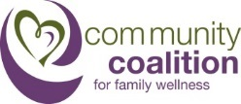
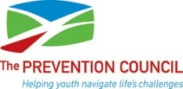

New initiative
For Immediate Release –2/15/2017 Contact: James Norton 581-1230 ext. 3632
South Glens Falls, NY – The Community Coalition for Family Wellness (CCFW) will hold a Community Health Fair to promote its Super Power Your Parenting campaign. The CCFW Community Health Fair will take place from 10 am – 12 pm March 18th at the South Glens Falls Fire Station 2 located on Rt. 197 in Moreau. CCFW is calling for all South Glens Falls super parents to assemble and take part in the event.

The Super Power Your Parenting campaign highlights research that confirms parents are the number one influence on their teens’ decisions around substance use. The CCFW Community Health Fair supports parents and youth in the South Glens Falls community by bringing together various organizations and agencies from the local area committed to family wellness. offering every resource available to parents in the community. Parents, teens and younger children can engage in fun activities along with activities that will help keep their family safe.

The Health Fair will include Saratoga County Sheriffs Department car seat safety checks, a Operation SAFE CHILD Card child ID booth, and a bounce house provided by the South Glens Fall Chamber of comers. Along with information, activities and free give-aways from Fidelis Care, Center for Recovery, Saratoga County Public Health, Hudson Headwaters Health Network, US Army, and Sweethearts and Heroes, The Moreau Community Center and many others.
CCFW is an organization of caring community members working proactively to reduce youth substance use and risky behavior, while providing families with resources, education, and activities that promote safety, health, and wellness.

For more information please contact:
James Norton, Partnership for Success Grant Coordinator Community Coalition for Family Wellness
The Prevention Council
125 High Rock Ave.
Saratoga Springs, NY, 12866
581-1230 x3632
ccfw-pfs@preventioncouncil.org
About The Prevention Council

The Alcohol and Substance Abuse Prevention Council of Saratoga County, Inc, is a nonprofit, community-based organization. Our mission is to provide education, information and referral services on the subjects of alcohol, tobacco, other drug and violence prevention to individuals and local communities, thereby enhancing the quality of life for all citizens by diminishing the adverse effects of substance abuse and viol

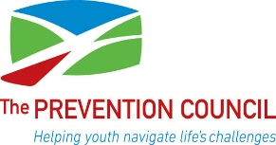
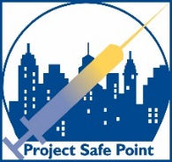
You Can Save A Life!

FREE One Hour Training in
Heroin/Opioid Overdose Prevention

A class is offered every month: 4 pm – 5 pm
Saratoga Springs Library
Susman Room -Tuesday January 10th
Susman Room -Tuesday February 14th
Glasby Room-Tuesday March 14th

- Learn the signs and symptoms of heroin and opioid overdose.

- Learn how to use NARCAN to respond to an overdose situation.

- Receive a FREE Naloxone (NARCAN) kit to carry and use.

To register or for more information contact
The Prevention Council at 581-1230 x3632
or ccfw-pfs@preventioncouncil.org
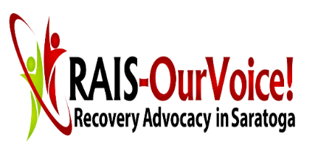
Walk-ins welcome
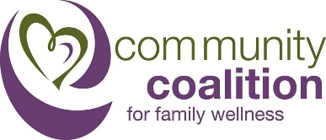
For other NARCAN training dates contact
Project Safe Point of Catholic Charities
at 449-3581 x130

